**DIGITAL-NURTURE-4.0- JAVA FSE**

**WEEK-2 SL4J**

**Exercise 1: Logging Error Messages and Warning Levels**

***pom.xml***

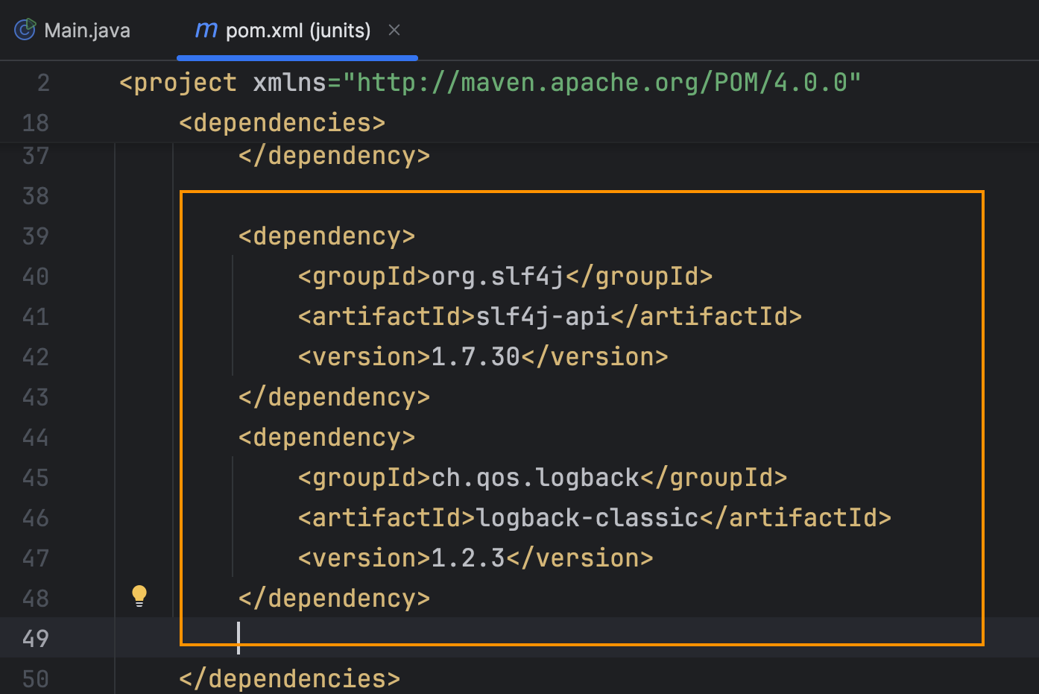

***LoggerExample.java***

package net.javaguides;

import org.slf4j.Logger;

import org.slf4j.LoggerFactory;

public class LoggingExample {

    private static final Logger *logger* = LoggerFactory.*getLogger*(LoggingExample.class);

    public static void main(String[] args) {

*logger*.info("Application started.");

        try {

            String value = null;

            if (value == null) {

*logger*.warn("Warning:'value' is null.");

            }

            int result = 10 / 0;

        } catch (ArithmeticException ex) {

*logger*.error("Error: Division by zero ", ex);

        }

*logger*.info("Application finished.");

    }

}

**Output**

